Name

Mathematics Stage 5 Paths
Similar Triangles

Book 1 |  | Version: 261007  Feedback:  https://MrDingMaths.com
Contents
Syllabus Content 2
Learning Intention 3

Syllabus Content
MA5-GEO-P-01 establishes conditions for congruent triangles and similar triangles and solves problems relating to properties of similar figures and plane shapes
Develop and apply the minimum conditions for triangles to be similar
- Examine the minimum conditions needed and establish the 4 tests for 2 triangles to be similar
- Apply the minimum conditions needed and determine whether 2 triangles are similar using an appropriate test

Conditions for Similar Triangles

- Similar Triangle Tests
- Remember that two figures are similar if all angles are equal and all corresponding sides in equal ratio.
- There are four ‘tests’ that can be used to decide if two triangles are similar.
- Unlike the congruence tests, you must write the full reasoning every time.
SSS  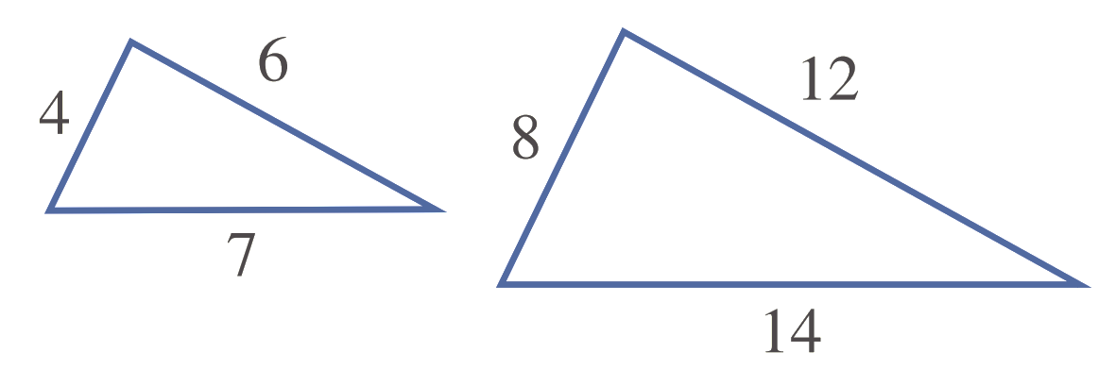  Three pairs of corresponding sides in the same ratio. | SAS  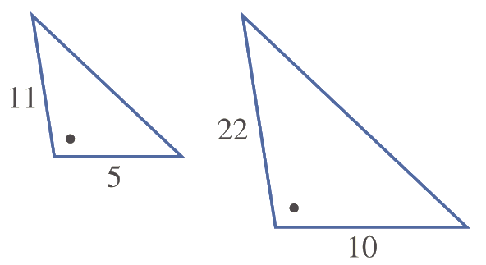  Two pairs of corresponding sides in the same ratio and the included angle equal.
AAA  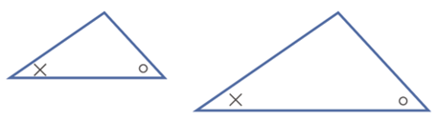  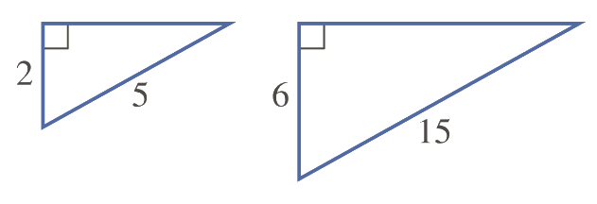  At least two pairs of equal corresponding angles. (If there are two equal pairs, the third must be equal) | RHS  For a right-angled triangle, the hypotenuses and another pair of corresponding sides in the same ratio.

- Identify congruent triangles using the four congruence tests
Which of the tests (SSS, SAS, AAA or RHS) prove the similarity of these pairs of triangles?
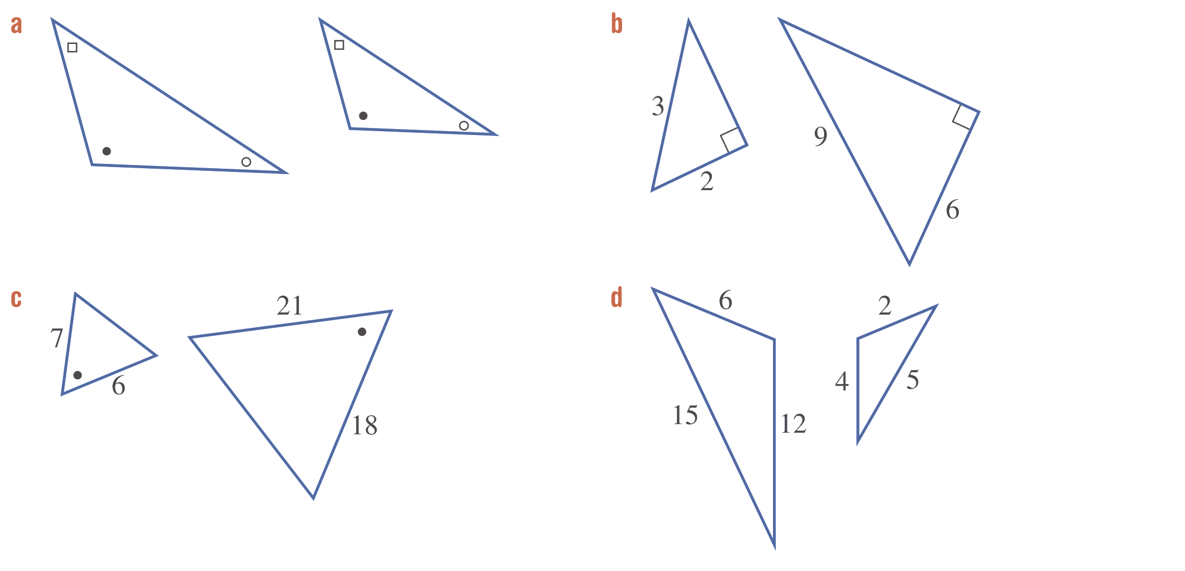

Foundation
- Consider these two triangles.
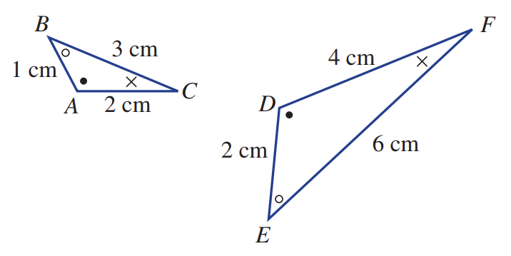
  - Name the angle on the larger triangle that corresponds to:
    - ∠A ……… ii ∠B ……… iii ∠C ………
$∠D$ $∠E$ $∠F$
  - Name the side on the smaller triangle that corresponds to:
    - DE ……… ii EF ……… iii FD ………
AB BC CA
  - Find these side ratios.
    - $\frac{DE}{AB}$ ……… ii $\frac{EF}{BC}$ ……… iii $\frac{FD}{CA}$ ………
2 2 2
  - Explain why the two triangles are similar.
Corresponding angles are equal. Corresponding sides are in the same ratio.

- Write a similarity statement for these pairs of similar triangles; for example, △ABC ||| △DEF.
Be careful with the order of letters and make sure each letter matches the corresponding vertex.
Also state the reason.
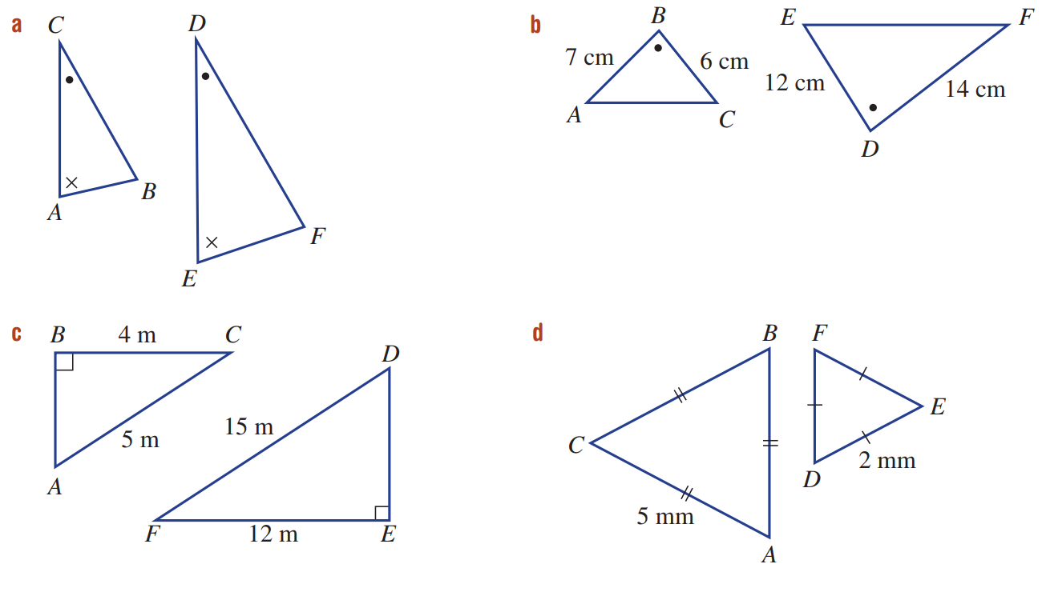  $Δ$ ……… $|||$ $Δ$ ……… (AAA)  ABC ||| EDF  At least ……… pairs of ……………… angles.  2, equal | $Δ$ ……… $|||$ $Δ$ ……… (SAS)  ABC ||| FDE  ………… pairs of corresponding sides in the same …………… and the …………… angle equal.  2, ratio, included
$$ΔABC|||DEF$$  the hypotenuses and another pair of corresponding sides in the same ratio. | $$ΔABC|||DEF$$  Three pairs of corresponding sides in the same ratio.

- Choose the similarity test that proves that these pairs of triangles are similar.
You must write the full reasoning.
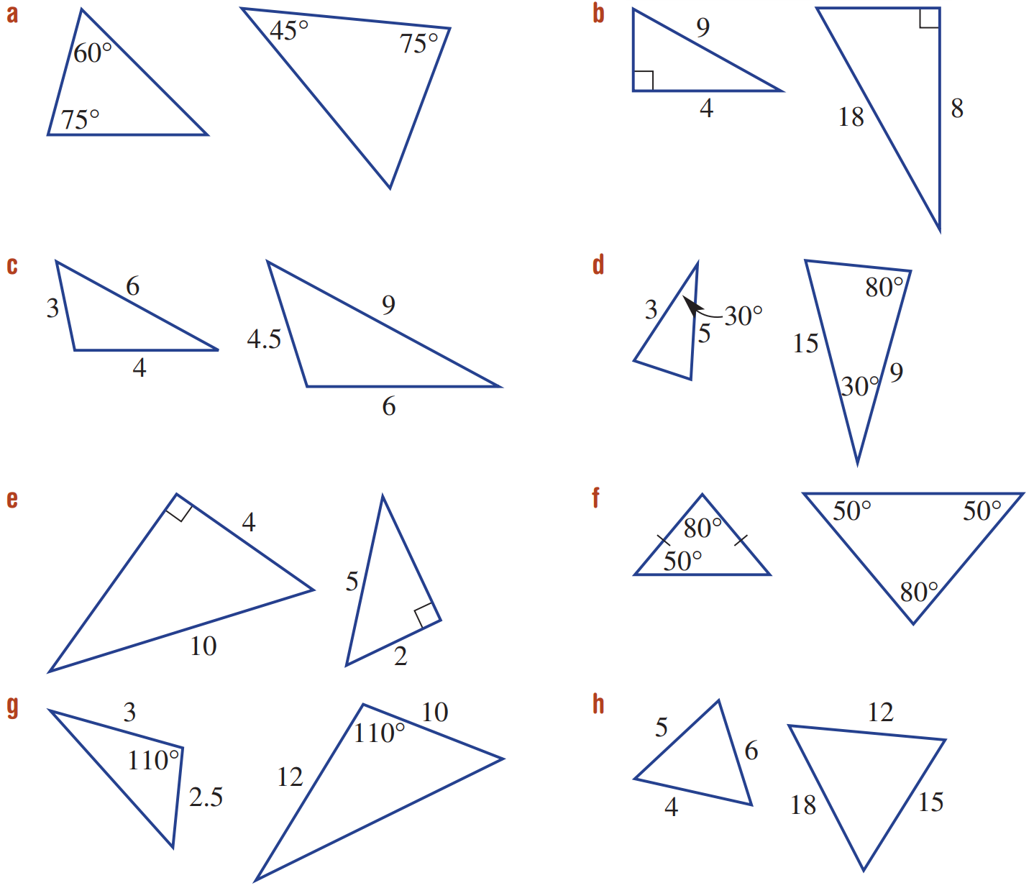  At least two pairs of equal corresponding angles. | the hypotenuses and another pair of corresponding sides in the same ratio. | Three pairs of corresponding sides in the same ratio.
Two pairs of corresponding sides in the same ratio and the included angle equal. | the hypotenuses and another pair of corresponding sides in the same ratio. | At least two equal pairs of corresponding angles.
Two pairs of corresponding sides in the same ratio and the included angle equal. | Three pairs of corresponding sides in the same ratio.

- State, with reasons, why these triangles are similar.
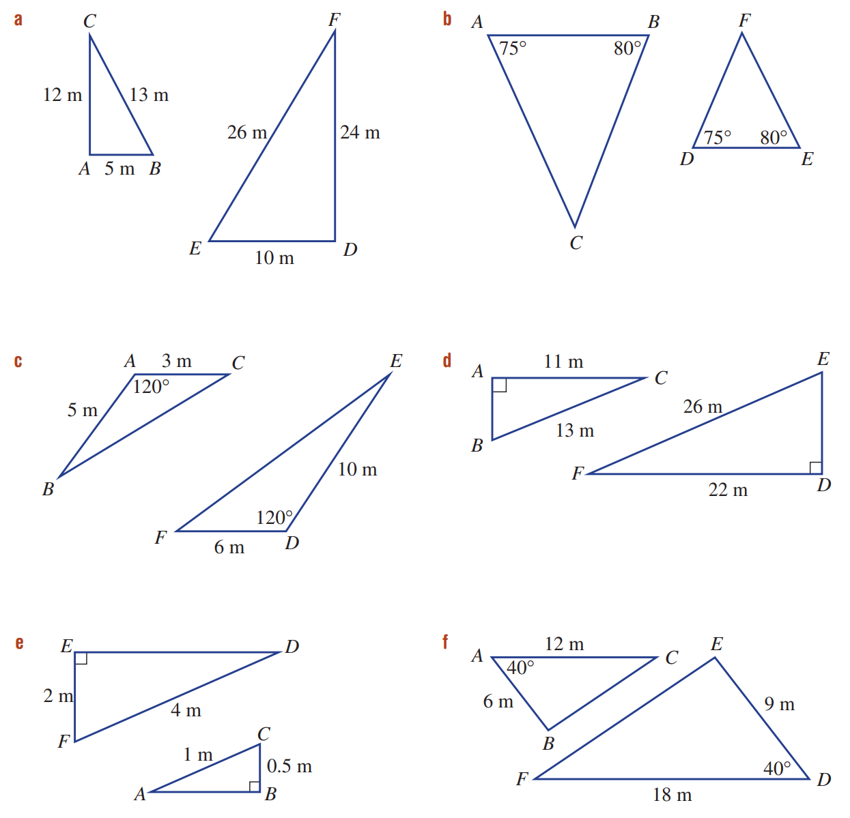  Three pairs of corresponding sides in the same ratio. | At least two pairs of equal corresponding angles.
Two pairs of corresponding sides in the same ratio and the included angle equal. | For a right-angled triangle, the hypotenuses and another pair of corresponding sides in the same ratio.
For a right-angled triangle, the hypotenuses and another pair of corresponding sides in the same ratio. | Two pairs of corresponding sides in the same ratio and the included angle equal.

Development
- For this pair of triangles:
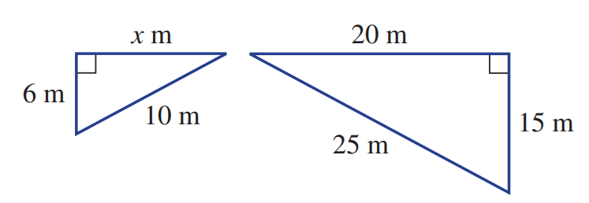
  - Identify why the two triangles are similar

For a right-angled triangle, the hypotenuses and another pair of corresponding sides in the same ratio.
  - find the value of $x$
$$\frac{x}{20}=\frac{6}{15}$$
$x=8$ m
- For this pair of triangles:
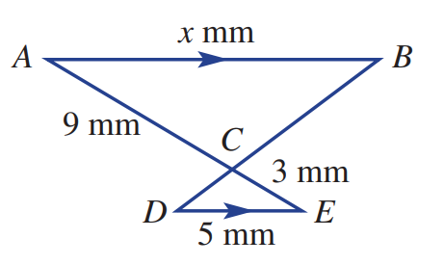
  - Identify why the two triangles are similar

At least two pairs of equal corresponding angles.
  - find the value of $x$
$$\frac{x}{5}=\frac{9}{3}$$
$x=15$ mm
- For this pair of triangles:
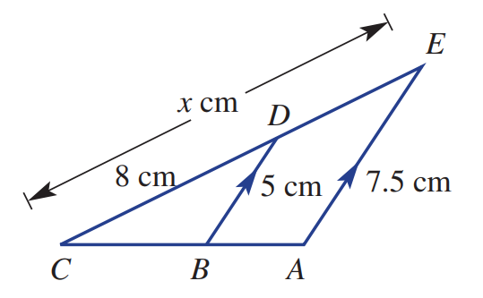
  - Identify why the two triangles are similar

At least two pairs of equal corresponding angles.
  - find the value of $x$
$$\frac{x}{8}=\frac{7.5}{5}$$
$$x=12$$
- By using the angle sum of a triangle, decide if the given pairs of triangles are similar.
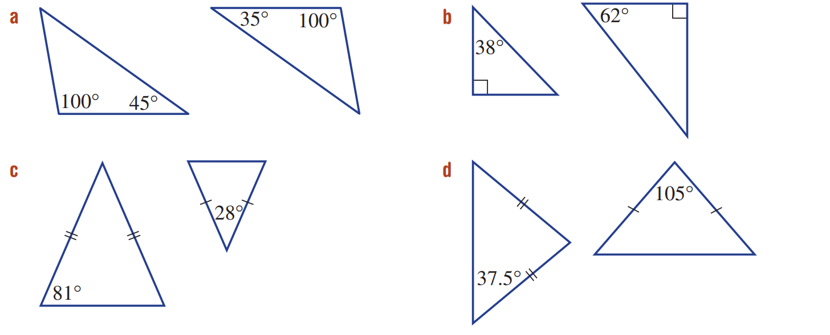  yes | no
no | yes
- For each set of three triangles, choose the two that are similar.
Choose the appropriate test and write a similarity statement (e.g. ΔABC ~ ΔFGH).
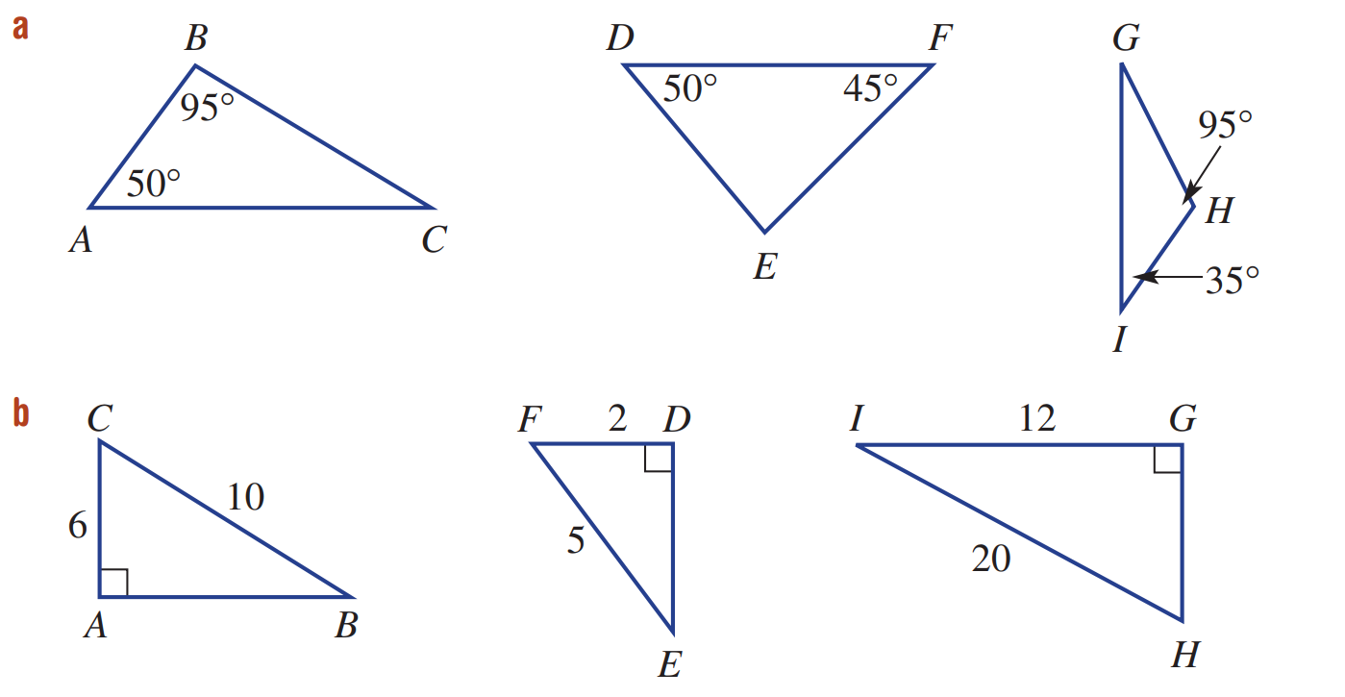

ABC ||| GHI
At least two pairs of corresponding angles.

ABC ||| GHI
For a right-angled triangle, the hypotenuses and another pair of corresponding sides in the same ratio.
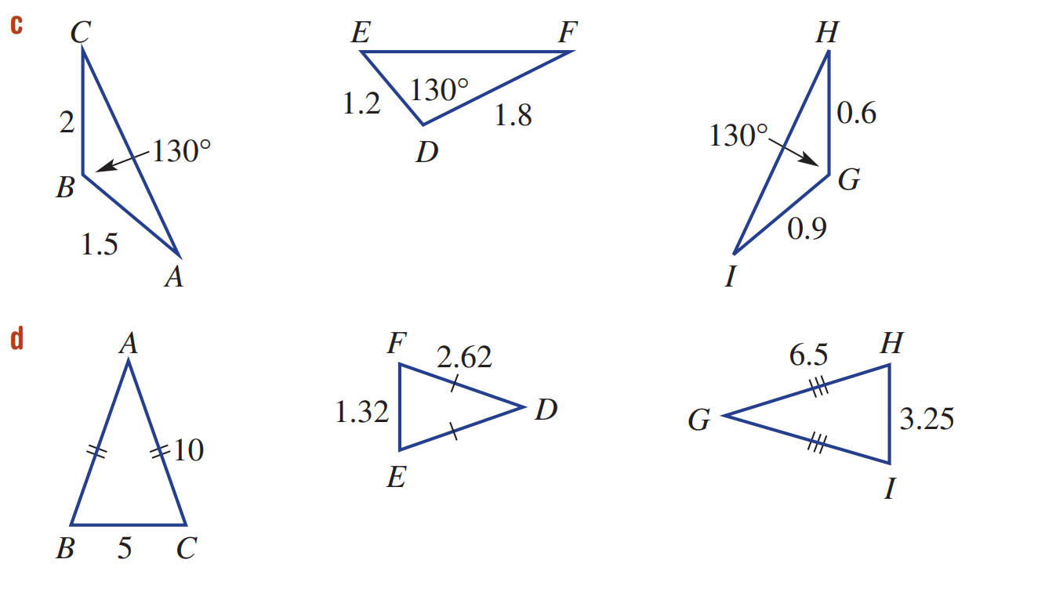

DEF ||| GHI
Two pairs of corresponding sides in the same ratio and the included angle equal.

ABC ||| GHI
Three pairs of corresponding sides in the same ratio.

Mastery
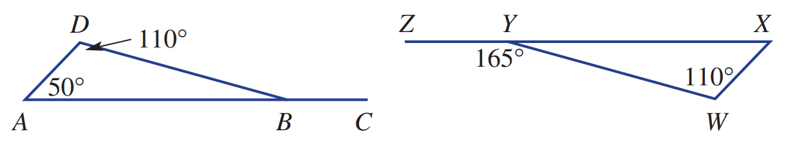
- Give reasons why the two triangles in these diagrams are not similar.

$∠DBA=20°,$but $∠XYW=15°$
Corresponding angles are not equal
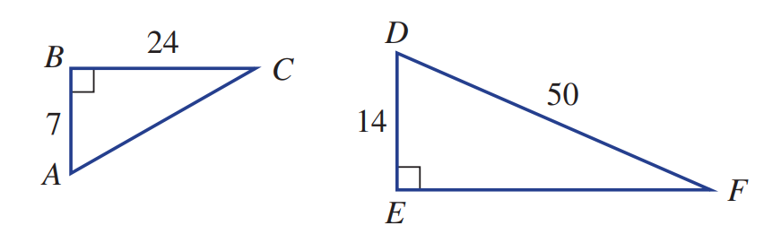
- Using Pythagoras’ theorem, show that these two triangles are similar.

$$AC=\sqrt{7^{2}+{24}^{2}}=25$$
$$EF=\sqrt{{50}^{2}-{14}^{2}}=48$$
$$\frac{AC}{DF}=\frac{AB}{DE}=\frac{BC}{EF}=2$$
Three pairs of corresponding sides in the same ratio.
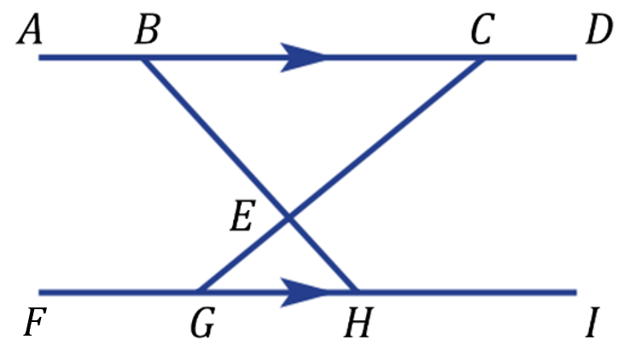
- When two intersecting transversals join parallel lines, two triangles are formed.
Explain why these two triangles are similar. Show full reasoning.

$∠CBE=∠EHG$ (alternate angles on || lines)
$∠BCE=∠EGH$ (alternate angles on || lines)
$∴ΔBEC ||| ΔHEG$ at least two pairs of corresponding angles.
$∠BEC=∠GEH$ (vertically opposite) (not necessary, but another option)

- Explain why these triangles are similar. Show full reasoning.
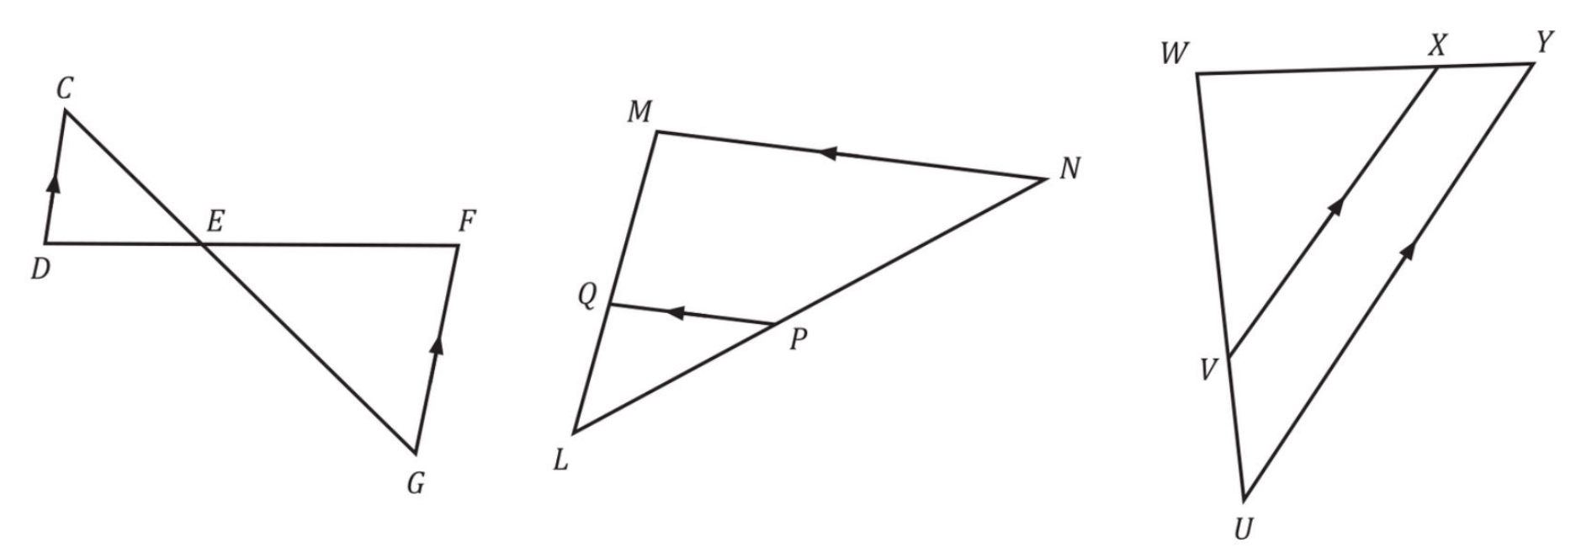  $∠DCE=∠FGE$ (alternate angles on || lines)  $∠CDE=∠GFE$ (alternate angles on || lines)  $$ΔCDE ||| ΔGFE$$  At least two pairs of equal corresponding angles. | $∠L$ is common  $∠LQP=∠LMN$ (corresp angles on || lines)  $$ΔLQP ||| ΔLMN$$  At least two pairs of equal corresponding angles. | $∠W$ is common  $∠WVX=∠WUY$ (corresp angles on || lines)  $$ΔWVX ||| ΔWUY$$  At least two pairs of equal corresponding angles.

- 2018 HSC Extension 1 Band 4
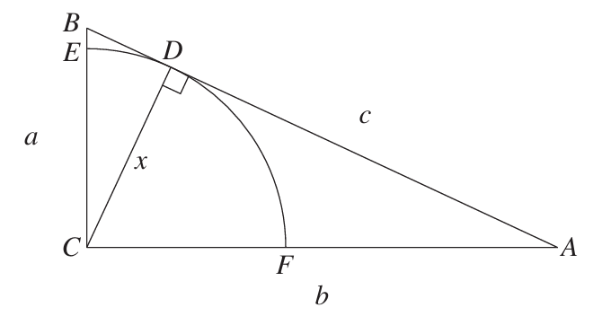
In triangle $ABC$, $BC$ is perpendicular to $AC$.
Side $BC$ has length $a$, side $AC$ has length $b$ and side AB has length $c$.
A quadrant of a circle of radius $x$, centred at $C$, is constructed. The arc meets side $BC$ at $E$.
It touches the side $AB$ at $D$, and meets side $AC$ at $F$. The interval $CD$ is perpendicular to $AB$.
  - Show that $ΔABC$ is similar to $ΔACD$.

In △ABC and △ACD
∠ACB = ∠ADC (CD perpendicular to AB, △ABC right-angled at C)
∠BAC = ∠CAD (common)
∴ △ABC ||| △ACD (equiangular)

  - Show that $x=$ $\frac{ab}{c}$
$$\frac{x}{a}=\frac{b}{c} (corresponding sides of similar triangles)$$
$$∴x=\frac{ab}{c}$$

